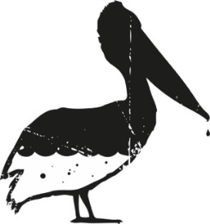

TEA TIME
FRESH & HOMEMADE
BOSSI’S BEST 8.50
Fresh Ginger, Fresh Mint, Honey, Fresh Lemon

GINGER LEMON 8.00

Fresh Ginger, Honey, Fresh Lemon

MINT & HONEY 7.50
Fresh Mint, Honey

For the cold days with a dash of Rum! +5.00

TEA IN BAGS 30cl

Darjeeling 5.50
Verveine 5.50
Green 5.50
Rooibos 5.50

APERITIFS Vol.% 4cl
Amaro Ramazzotti 30 10.50

Amaro Averna 29 10.50
Antica Formula 17 16.50
Jsotta Red 18 11.50
Jsotta Rosé 17.5 11.50
Jsotta White 18 10.50
Jsotta Bitter 23 10.50
Jsotta Senza 0 8.50

Cynar 16.5 10.50

Fernet Branca 39 11.50
Noilly Prat 15 10.50
Pastis - Ricard 45 11.50
Pimm’s No.1 25 10.50

OK I’LL HAVE ONE
Lillet Spritz White-Rosé 15.00
Jsotta Bitter Spritz 15.00
Aperol Spritz 15.00
Bellini 16.50
Gespritzter Sweet / Sour 11.50
Hugo 15.00

IN VINO VERITAS 10cl 75cl
WHITE


Kaufleuten Wine 8.50 59.00

Rueda DO, Spain
Verdejo

Chardonnay Süd-Dalmatien 10.50 76.00
Dubrovacki Podrumi d.d Chardonnay

ROSÉ
Whispering Angel 10.50 76.00
Côte du Rhone, France
Cinsault, Mouvédre, Grenache, Syrah

RED
Château Moulin,Bordeaux France 11.50 84.00
Cabarnet Sauvignon,Cabarnet Franc,Malbec,Merlot

Kaufleuten Wine 10.00 69.00
Ripasso Superiore,Tinazzi Italien
Corvina,Corvinone,Rondinella,Negrara

Mauro Tinto,Cosecha Tudela,Ribera del Duero 12.50 89.00
Spanien,
Tempranillo&Syrah

OH SWEET CAFFEINE
Americano 6.50
Café 5.50
Cappuccino 6.50
Chocolate Coatina 6.50
Corretto 9.50
Doppio 6.50
Doppio Macchiato 7.00
Espresso 5.50
Espresso Macchiato 5.50
Iced Coffee 8.50
Latte Macchiato 6.50
Schale 6.50

Alternative Milk
Almond
Lactose free
Soy
Oat

Do you like our coffee?
Take it home!
Black & Blaze 1 kg CHF 38.00

SOFTIES

Bitter Lemon Organics 25cl 5.50
Pepsi 30cl 5.50

Pepsi Zero 30cl 5.50

Chinotto 20cl 5.50

Gazzosa Bitterorange / Limone / Mirtillo 35cl 7.00

Pelibar Ice Tea-Homemade 40cl 7.50
Red Bull 25cl 7.50
Red Bull Summer Edition Weisser Pfirsich 25cl 7.50
Red Bull Sugarfree 25cl 7.50
Sanbitter 10cl 5.50
Ginger Beer-Tonic-Ginger Ale Thomas Henry 25cl 5.50
Rhäzünser Sparkling 40cl 6.00
Arkina Silence 40cl 6.00
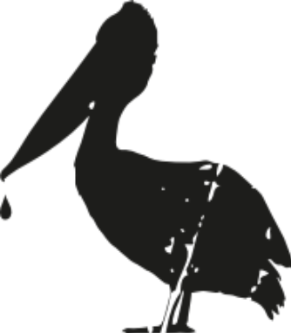

BUBBLES 10cl 75cl

Prosecco – Vivo 9.50 69.00

Veneto, Italien

Veuve Clicqout Brut 17.00 129.00

Moët & Chandon 16.50 110.00

Champagne, France
Pinot Noir, Pinot Meunier, Chardonnay

Moët & Chandon Nectar Impérial 180.00

Champagne, France
Pinot Noir, Pinot Meunier, Chardonnay

Moët & Chandon Ice 155.00
Champagne, France
Pinot Noir, Pinot Meunier, Chardonnay

Ruinart Blanc de Blanc-Rosé 185.00
Champagne, France
Chardonnay

Armand de Brignac Gold, Flasche 545.00
Champagne, France
Pinot Noir, Pinot Meunier, Chardonnay

GOLD IN THE GLASS
DRAUGHT BEER 30cl 50cl
Helvetic 6.00 9.50

Valaisanne 6.00 9.50

Panache 6.00 9.50

BEAUTY IN A BOTTLE

Schneider Weisse 50cl 9.50
Valaisanne 33cl 8.50
Feldschlösschen 0.0% 33cl 7.50
San Miguel Fresca 33cl 8.50
Saison Bier 33cl 8.50

SHOTS Vol.% 4cl
Absinthe Kübler 53 15.50

Belvedere 40 16.50
Berliner Luft 18 9.50
Altos Blanco 40 12.50
Altos Reposado 40 13.50
Avion 44 40 45.00
Clas Azul 40 45.00
Don Julio 1942 38 45.00
Hierbas 26 9.50
Jägermeister 35 9.50
Sambuca Ramazzotti 38 9.50

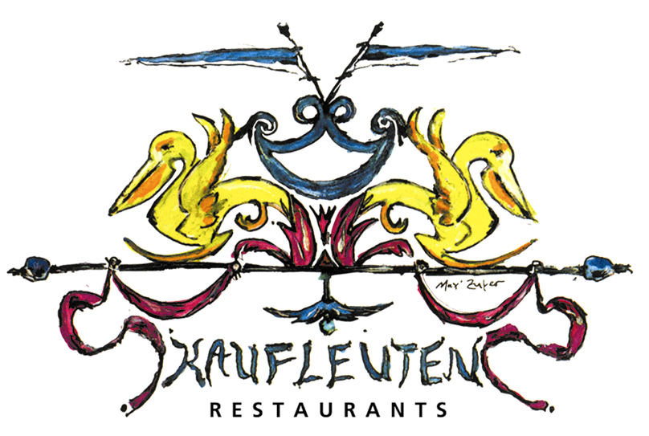

WHISKEY Vol.% 4cl

Four Roses 45 15.50

The Deacon 35 16.00
Chivas 12y 40 15.00
Chivas 18yrs 40 35.00
Jack Daniels 40 15.50
Oban 14yrs 43 18.50
Talisker 10yrs 45.8 18.50
The Balvenie 12yrs 43 18.50
The Glenlivet 12yrs 40 18.00
The Macallan Double Cask 40 21.50
Johnnie Walker Gold Label 40 21.50

GRAPPA & CO. Vol.% 2cl
Etter Williams, Williams 40 9.50

Gensac Armagnac 5 ans 40 15.50

Grappa Fior di Vite 43 14.50

Tre Soli Tre, Berta, Nebbiolo 45 18.50
Pisco, Muscat d’Alexandria 40 15.50

PELIBAR FAVOURITES
JSOTTA ROSÉ & TONIC 15.00
Jsotta Rosé Vermouth, Tonic

PALOMA 18.00
Altos blanco, Paloma Pink Grapefruit,
Fresh Lime Juice, Pink Himalayan Sea Salt

ROSEMARY NEGRONI 19.00
Jsotta Red Vermouth, Beefeater Gin, Jsoatta bitter,
Rosemary, Lemongrass, Orange Bitter

MALFY SOUR 20.00
Malfy Rosa Gin, Fresh Lemon Juice,
Agave Syrup, Egg White

WILD BERRY SPRITZ 17.00
Prosecco, Chambord, Lime, Alpines Wild Berry

Italicus Spritz 18.50
Prosecco,Italicus,Oliven

MODERN CLASSICS
BASIL SMASH 18.50
KiNobI Gin, Fresh Lemon Juice,
Fresh Basil, Sugar Syrup

BLACK / WHITE RUSSIAN 18.50
Absolut Vodka, Amarula / Cream

COSMOPOLITAN 18.50
Absolut Vodka, Cointreau, Cranberry Juice,
Fresh Lime Juice

DAIQUIRI 18.50
Havana 3 Anos, Fresh Lime Juice, Sugar Syrup

GIN / VODKA FIZZ 18.50
Beefeater Gin / Absolut Vodka,
Fresh Lemon Juice, Sugar Syrup, Soda Water

GIN / VODKA GIMLET 18.50
Beefeateer Gin / Absolut Vodka,
Fresh Lime Juice, Sugar Syrup
SPIRITS Vol.% 4cl
GIN
Beefeater 43.1 13.50

Beefeater 24 47.3 18.00
Malfy Rosa 41.3 15.50
Monkey 47 47 16.50
Plymouth 41 15.50
Ki NO Bi 41.3 18.00
Gin Mare 42.7 15.50
Hendrick’s 41.4 15.50
Turicum N°3 41.5 15.50
RUM
Havana 3 Anjos 37.5 13.50
Havana Especial 40 13.50
Havana 7 Anjos 40 16.00
Bumbu 40 19.00
Bumbu XO 40 32.00
Diplomatico Riserva Exclusiva 40 19.00
TEQUILA & MEZCAL
Altos Blanco 40 12.50
Altos Reposado 40 13.50
Avion 44 40 45.00
Clas Azul 40 45.00
Mezcal 45 15.50
VODKA
Absolut 40 13.50
Elyx 40 15.50
Belvedere 40 16.50
FANCY & FRESH MOCKTAILS
IPANEMA 13.50
Ginger Ale, Fresh Lime Juice

MANGO MANDARIN SOUR 13.50
Mango Syrup, Mandarin Syrup, Egg White,
Beefeater 0.0%

Aperol Spritz (alkoholfrei) 13.50

Hugo (alkoholfrei) 13.50

GET JUICY
Apple 30cl 5.50
Cranberry 30cl 5.50

Fresh Orange 20cl 8.50
Grapefruit 30cl 5.50
Orange 30cl 5.50
Ananas 30cl 5.50
Passionfruit 30cl 5.50
Pineapple 30cl 5.50
Tomato 20cl 5.50
CLASSICS-PELIBAR
MOSCOW MULE / LONDON MULE 18.50
Absolut Vodka / Beefeater Gin,
Fresh Lime Juice, Ginger Beer

NEGRONI 18.50
Beefeater Gin, Jsotta bitter, Jsotta Red

PORNSTAR MARTINI 25.50
Absolut Vodka, Juice, Möet & Chandon Champagne

OLD FASHIONED 18.50
Four Roses, Angostura, Sugar Syrup,
Soda Water

PIMM’S NO. 1 18.00
Pimm’s No.1, Ginger Ale, Fresh Mint, Strawberries,
Cucumber, Orange

TRINIDAD SOUR 18.50
Angustura, Four Roses Whiskey, Almond Syrup, Lemon Juice

Ibiza Mule 18.50
Hierbas,Fresh Lime Juice,Ginger Beer(by Mumi)

CLASSICS WITH A TWIST
BLOODY MARY 18.50
Absolut Vodka, Tomato Juice, Fresh Lemon Juice,
Salt, Pepper, Tabasco, Sambal Oelek, Spices

DARK & STORMY 18.50
Havana Especial, Fresh Lime Juice, Spicy Ginger
ESPRESSO MARTINI 18.50
Absolut Vodka, Kahlua, Espresso, White Cacao

MOJITO-CAIPIRINHA 18.50
Havana 3 Anos, Fresh Lime, Sugar Syrup,
Mintfoam, Soda Water

PELIBAR SOURS
Amaretto Sour 18.00
Aperol Sour 18.00
Averna Sour 18.00
Campari Sour 18.00
Diplomatico Sour 22.00
Gin Sour 18.00
Hierbas Sour(by Mumi) 18.00
New York Sour 20.00
Pisco Sour 18.00
Ramazzotti Sour 18.00
Smokey Pisco Sour 18.50
Tequila Sour 18.00
Vodka Sour 18.00
Whiskey Sour 18.00
Ginger Sour 18.00

Fresh Lemon / Lime Juice, Sugar Syrup, Egg White

